# Sort DataFrame By Date

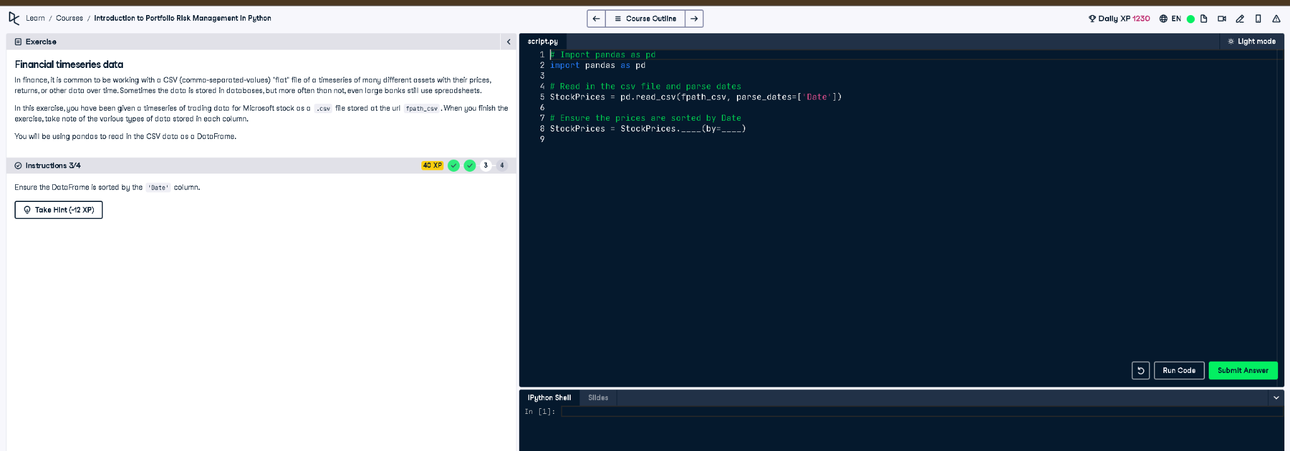

## Python Code

# Import pandas as pd  
import pandas as pd  
  
# Read in the csv file and parse dates  
StockPrices = pd.read_csv(fpath_csv, parse_dates=['Date'])  
  
# Ensure the prices are sorted by Date  
StockPrices = StockPrices.sort_values(by='Date')

## Explanation

This task ensures the DataFrame is ordered by the 'Date' column. Sorting by date is important when working with time series data to make sure data trends and calculations happen in the correct order. The sort_values() method arranges rows by the 'Date' column.